
Web: | www.anbobio.com  www.dijibio.com
Order: | order@dijibio.com
Tel: | (86) 519 8805 0026
Web: | www.assaybiotech.com
Order: | order@assaybiotech.com
Tel: | 1-877-883-7988 (Free in USA)
Web: | www.anbobio.com
Order: | order@anbobio.com
Tel: | 4000-234-432
Web: | www.anbobio.com
Order: | order@anbobio.com
Tel: | 4000-234-432

RPL14 Antibody [#C14151]

----------------------------------------------------------------------------------------------------------------------------------------------------------------

Catalog Number: C14151
Concentration: 1mg/ml
Swiss-Prot No.: P50914
Other Names: CAG-ISL-7; CTG-B33; hRL14; L14; MGC88594; ribosomal protein L14; RL14
Storage/Stability: Store at -20℃/1 year
Form of Antibody: Rabbit IgG in phosphate buffered saline (without Mg²⁺ and Ca²⁺), pH 7.4, 150mM NaCl, 0.02% sodium azide and 50% glycerol.
Immunogen: The antiserum was produced against synthesized peptide derived from internal of human RPL14.
Purification: The antibody was affinity-purified from rabbit antiserum by affinity-chromatography using epitope-specific immunogen.
Specificity: RPL14 antibody detects endogenous levels of total RPL14 protein.
Reactivity: Human (Identities = 100%, Positives = 100%);
Mouse (Identities = 92%, Positives = 100%);
Rat (Identities = 92%, Positives = 100%)
Applications: WB: 1:500~1:3000 ELISA: 1:5000
References:
Aoki M., Diabetes 45:157-164(1996).
Tanaka M., Biochem. Biophys. Res. Commun. 243:531-537(1998).
Yoshihama M., Genome Res. 12:379-390(2002).

----------------------------------------------------------------------------------------------------------------------------------------------------------------
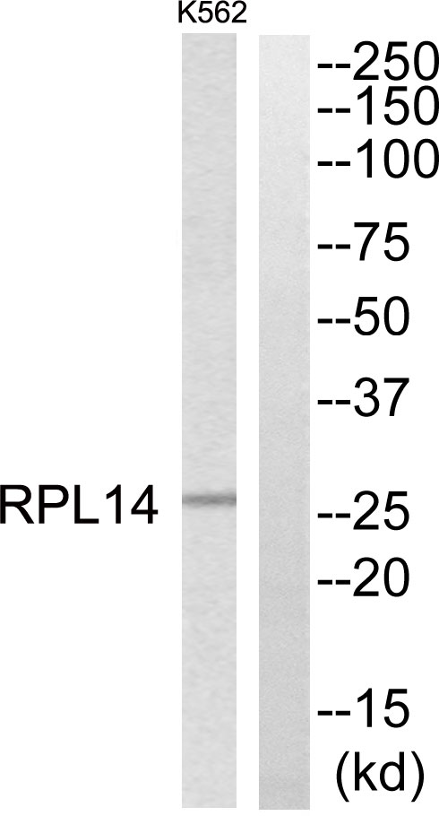
Peptide | - | +

Western blot analysis of extracts from K562 cells, using RPL14 antibody.

